Signali i sustavi – vježba br. 5 JOSIP PERAK

Zadatak 4.

________________________________________________________________________________________________________________________________________________________________________________________________________________________________________________________________

G1_br=[4]; G1_naz=[1];
G2_br=[1]; G2_naz=[1,1];
G3_br=[1,0]; G3_naz=[1,0,2];
G4_br=[1]; G4_naz=[1,0];
H1_br=[4,2]; H1_naz=[1,2,1];
H2_br=[50]; H2_naz=[1];
H3_br=[1,2]; H3_naz=[1,14];

[PV1_br,PV1_naz]=feedback(G4_br,G4_naz,H2_br,H2_naz,+1);
[SV1_br,SV1_naz]=series(G2_br,G2_naz,G3_br,G3_naz);

[PV2_br,PV2_naz]=feedback(SV1_br,SV1_naz,H1_br,H1_naz,-1);
[SV2_br,SV2_naz]=series(PV2_br,PV2_naz,PV1_br,PV1_naz);

[PV_br,PV_naz]=feedback(SV2_br,SV2_naz,H3_br,H3_naz,-1);
[W_br,W_naz]=series(G1_br,G1_naz,PV_br,PV_naz);
printsys(W_br,W_naz)

pzmap(W_br,W_naz)
roots(W_br)
roots(W_naz)
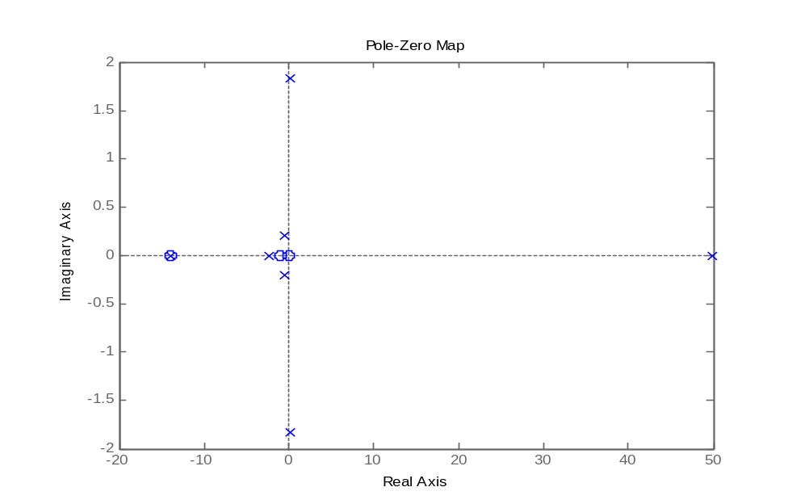

Slika 4.1 dijagram polova i nula prijenosne funkcije
Zadatak 5.

________________________________________________________________________________________________________________________________________________________________________________________________________________________________________________________________

G_br=[1,1]; G_naz=[1,4,6,10];
[W_br,W_naz]=cloop(G_br,G_naz);
printsys(W_br,W_naz)
roots(W_naz)

num/den =

s + 1
----------------------
s^3 + 4 s^2 + 7 s + 11

ans =

-2.8946
-0.5527 + 1.8694i
-0.5527 - 1.8694i

num/den =

s + 1
----------------------
s^3 + 4 s^2 + 7 s + 11

ans =

-2.8946
-0.5527 + 1.8694i
-0.5527 - 1.8694i

Zadatak 6.

________________________________________________________________________________________________________________________________________________________________________________________________
________________________________________________________________________________________________________________________________

T_br=[1]; T_naz=[1,2,1,1];
roots(T_naz)

step(T_br,T_naz)

figure(2)
impulse(T_br,T_naz)

t=0:0.01:50;
x=5*sin(3*t);
y=lsim(T_br,T_naz,x,t);
figure(3)
plot(t,x,'r',t,y)

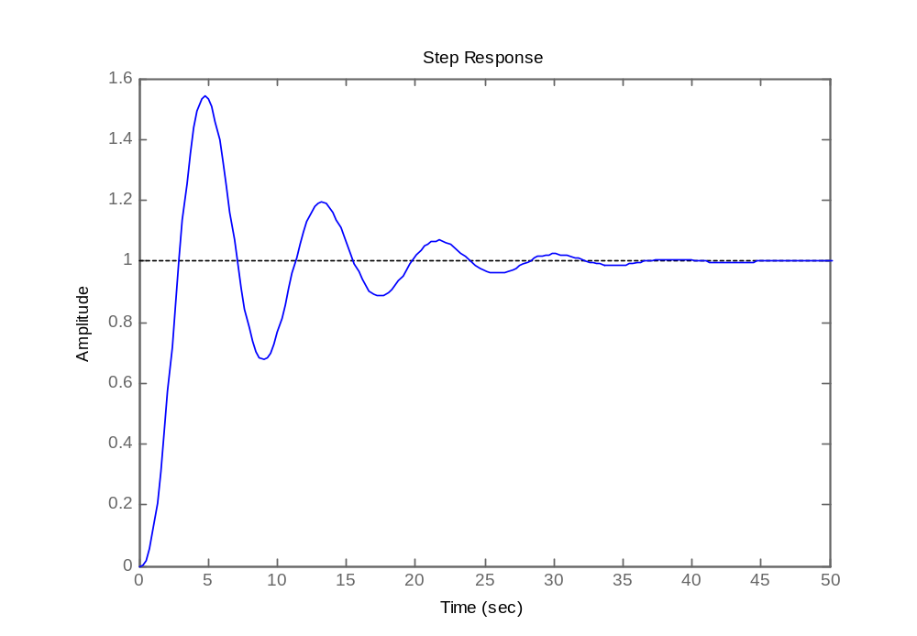

Slika 6.1 na ulaz dovedena step pobuda

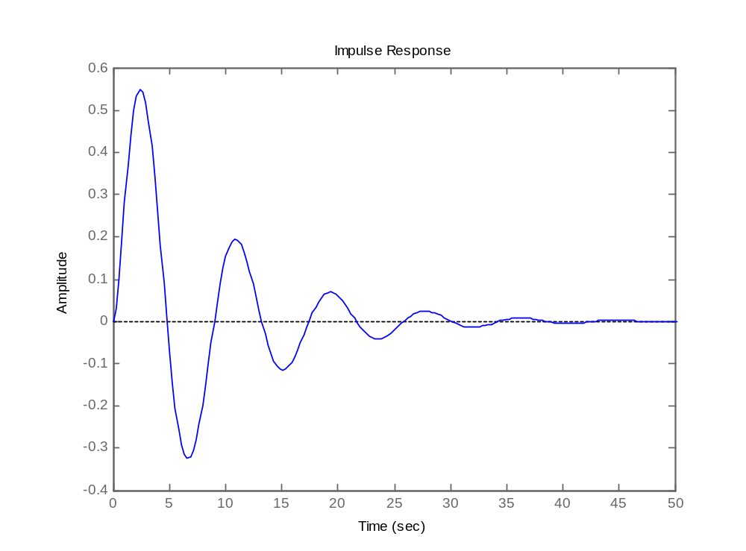

Slika 6.2 na ulaz doveden Diracov impuls

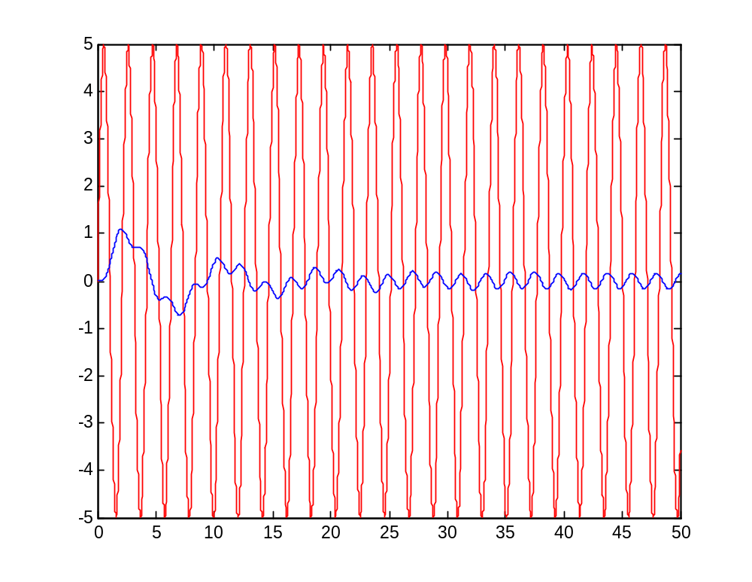

Slika 6.3 na ulaz dovedena sinusna pobuda x(t)=5sin(3t)

